DVM WebSpaces – Tasks and Work
Cary Grant Anderson
8/6/2014

Objectives:

- Develop an ASP.NET based website using DevExpress controls that I can use to replace my existing DVM websites and website template.
- Modular architecture so that I can add additional forms and pages easily (manually) to expand the website.
- CMS based functionality so I can expand, add to, and manage the websites without having to code ASP.NET or HTML files and upload them manually.
- Create additional modules to provide all the functionality I need for my membership websites.
- Eventually encompass all of the functionality of professional $20K+ CMSes including social site and shopping cart functionality.
- Start selling this commercially once I have #2 and/or #3 above complete.
- Sell this as a commercial alternative to existing CMS type products.

Primary Tasks:

- Finish base development of the Main Frame page that houses everything.
  - See below old task lists to integrate in.
  - Make 2 versions:
    - Full Screen, and
    - Backgrounded Screen (like most conventional web pages).
  - Nav Bar with support for ASP.NET pages, HTML pages, and DVM Link files from a Nav Tree Pages directory.
  - Main Menu with support for pulling menu items from a Main Menu Tree Pages directory, DVM Link files, XML file, and/or a database table or query.
    - See the DevExpress How To and KB entries for this.
  - Header definition loading from a settings file.
  - Background image setting/selection support.
  - DevExpress theme support – Dynamic during runtime.
  - Logging – 3 Levels:
    - User login/logout/expire.
    - User actions.
    - System and user errors.
- Add login and registration support to the Main Frame.
  - See how other webpages and such do this.
  - Support local files and also SQL Server for member information and settings.
- Explore optional footer support.
  - Add a frame for this?
  - Will a footer div work?
  - Can I dynamically turn it on and off?
  - And specify contents for it?
  - And can I do a dynamic Fixed Size (Height) option settings so that the footer displays at all times?
- Standardized page not found error page.
  - And customized versions without having to change code.
- What else?
  - What else was in my Aspire framework which would be useful?
- Settings Page.
  - A basic Settings Page with settings.
  - Note: This may be a popup dialog.
- Add support for blogs via BlogEngine.NET.
  - http://www.dotnetblogengine.net/
- See features and functionality in other .NET CMSes:
  - See: http://n2cms.com/screenshots.aspx
  - See: http://sourceforge.net/projects/touchpointcms/

Old Tasks to Finish or Integrate In:

- Convert from individual theme files to themes DLL.

- Integrate in:

- My old Aspire code.

- My two sets of old and new DVM WebSpaces code.

- Merge them all together.

- Create a standard header with menu(s).

- Main menu.

- Settings menu (dropdown button).

- Allow for setting theme from here!

- Review the DevExpress ASP.NET demos and see what ideas they
offer.

- I can see a basic splitter based form with a header centered on a
background.

- With a button for full screen mode.

- And with the capabilities to use booster files to link in
other web pages and dynamically create web pages on the fly
from templates and such so users can just post text and it
will automatically be displayed in web pages.

- So they don't have to keep on editing web pages all
of the time.

- Or make custom grid pages and other such pages
every time.

- Review all of my old relevant documents and to do lists.

- Bring the to do lists up to date.

- Layout out this vision and start implementing it!

- Get header cleaned up with margins and top fixed pane height set correctly.

- Can I get it looking like my personal web page???

- Just set the background?

- And make the header without borders and such???

- Change over the Load on Demand via ASPxTreeView_Nav_VirtualModeCreateChildren to
load all?

- Or just keep this approach and change the code to accomodate this?

- OR JUST USE A TREE LIST?????

- Add the ASPxTree with loading from file system.

- Copy over the entire 2 stage approach from the DnF Tool so that
I can do a complete abstraction on top of the file system and
deal with special files in the site directory structure.

- Now add the content URL being loaded for HTML forms and ASP.NET pages.

- And display the target file in the content pane.

- Now add the ability to load XML or text files with special properties,
such as pointing to a specific URL (like Bing, etc.).

- Do a basic implementation of this.

- Ok, now what to do next???

- What do I need to make this a usable CMS like system?

- See what the other CMSes do in the code I have for them.

- Login.
- Register.
- Forgot Password, etc. pages.
- See that other project.
- Figure out the best way to implement security.

ASPxMenu KB Pages – Load from File or DB Table:

http://stackoverflow.com/questions/3404931/how-to-bind-aspxmenu-by-xml-file-value

http://books.google.com/books?id=PHLshinGQ4oC&pg=PT276&lpg=PT276&dq=devexpress+aspxmenu+load+from+file&source=bl&ots=tzFN-sr1Id&sig=Q2IEtalPD9odez1xj_JnX__R0p0&hl=en&sa=X&ei=_eLjU9tQg8TxAZf_gdgO&ved=0CCoQ6AEwAjgK#v=onepage&q=devexpress%20aspxmenu%20load%20from%20file&f=false

https://mbasic.facebook.com/notes/devexpress/displaying-content-from-an-aspxmenu-in-an-iframe/197017669523/?_rdr

http://psycodedeveloper.wordpress.com/2014/05/26/how-to-align-aspxmenu-items-on-both-left-and-right-hand-side/

http://forums.asp.net/t/1904214.aspx?Swap+in+a+submenu+based+on+a+main+menu+click

https://www.devexpress.com/Support/Center/Question/Details/DQ42250

https://www.devexpress.com/Support/Center/Question/Details/Q311589

http://www.devexpress.com/Support/Center/Question/Details/Q331801

http://www.devexpress.com/Support/Center/Question/Details/Q316083

http://www.devexpress.com/Support/Center/Example/Details/E49

http://codecentral.devexpress.com/E49/

http://www.codeproject.com/Questions/343414/how-to-avoid-the-page-refresh

http://demos.devexpress.com/ASPxNavigationAndLayoutDemos/Menu/Toolbars.aspx

http://demos.devexpress.com/ASPxNavigationAndLayoutDemos/Menu/Templates.aspx

http://demos.devexpress.com/ASPxNavigationAndLayoutDemos/Menu/DataBinding.aspx

https://demos.devexpress.com/ASPxNavigationAndLayoutDemos/Menu/TabbedMenu.aspx

WebSpaces Modules to Build:

- [ ] COMPLETE THIS!!!!
  - Go thru all the DevExpress demos and list useful things here!
  - See: C:\Grant\Google Drive\Dev - DVM WebSpaces Modules
  - Use modules found in other CMSes!!!
  - Review what’s in Report Portal too.
  - List dashboard widgets as well.
    - See my other older list.

Phase 1:

Modules I Already Have Mostly Complete:

- File Share – I already have a prototype done.
- Alphabet List Menu (ASPxTitleIndex) – I already have this done.
- Grid Editor/Database Table Editor – I already have this done.
- HTML Editor – I already have a prototype.

Modules to Build:

- Settings Module and Page Editor.
- Grid Viewer – Displays a grid of data.
- ASPxDataView control.
- ASPxNavBar control.
- ASPxCloud control.
- Slide Show Control – See the DevExpress Book.
- YouTube Player – See the DevExpress Book.
- ???

Phase 2:

- Tabbed Views/Panes using the ASPxPage control?
- Map Control.
- Web Dashboard – I already have this mostly complete in Aspire/ERD/EBT.
- Form Page – Displays forms dynamically from DVM Forms files.
- Chart Page.
- Tree List Viewer.
- Tree List Editor.
- Pivot Grid (with Chart).
- ???

Phase 3:

- Calendar.
- Schedular.
- WorkFlow Manager.
- E-Mail Notifier.
- Surveys, Quizes, and Tests.
- ???
- ???

Future:

- ???
- ???
- ???

Previous Tasks

Tasks:

- Go thru all of the DevExpress KB articles on the ASPxSplitter and determine best ways how to:
  - Use it full screen with a header.
  - Use it in an inner div with background image showing in a picture frame type webpage approach.
  - Determine how else best I can use it.

https://www.devexpress.com/Support/Center/Question/Details/Q323837

https://www.devexpress.com/Support/Center/Question/Details/Q322793

http://demos.devexpress.com/ASPxNavigationAndLayoutDemos/Splitter/FullscreenMode.aspx

https://www.devexpress.com/Support/Center/Attachment/GetAttachmentFile/07a2edbf-02d3-4146-8c16-414d4ea20419

https://www.devexpress.com/Support/Center/Question/Details/Q266595

http://www.devexpress.com/Support/Center/Question/Details/Q443563

https://www.devexpress.com/Support/Center/Question/Details/Q369724

http://www.devexpress.com/Support/Center/Question/Details/Q255647

https://www.devexpress.com/Support/Center/Question/Details/Q353132

http://www.devexpress.com/Support/Center/Question/Details/Q25003

http://stackoverflow.com/questions/21525023/devexpress-aspxsplitter-reload-just-the-right-side

http://demos.telerik.com/aspnet-ajax/splitter/examples/overview/defaultcs.aspx

http://www.kacode.com/v1646696-.html

http://demos.telerik.com/aspnet-ajax/splitter/examples/resizewithwindow/fullwindow.aspx

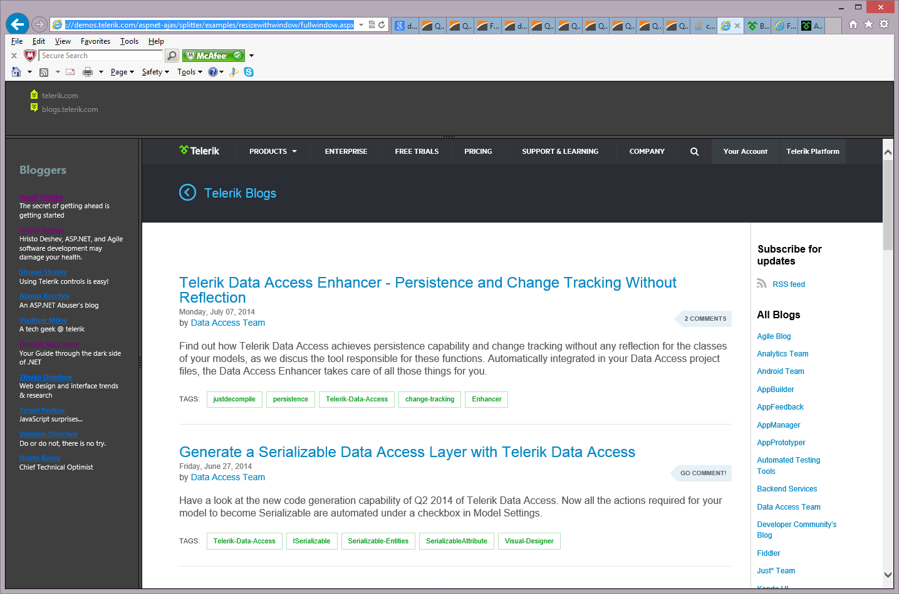

See:

C:\Grant\Google Drive\Dev – DVM WebSpaces

C:\Grant\Dropbox\Dev – Websites

C:\Grant\Dropbox\Dev - Websites\Dev - Web - CaryGrantAnderson.com

This is my current project results:

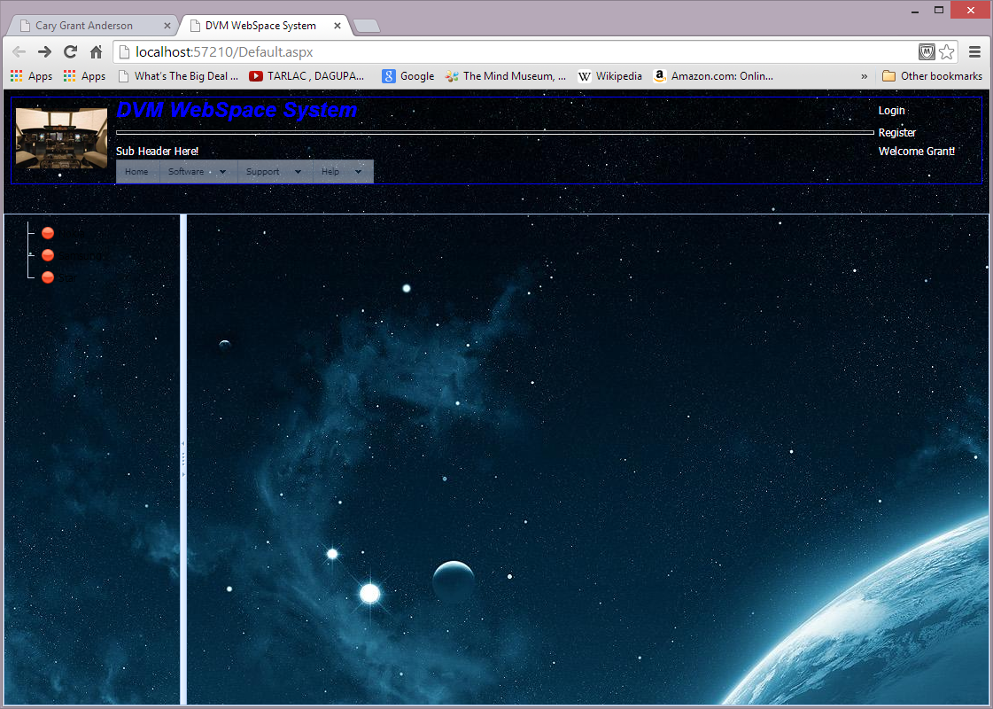

This is perhaps a better approach:

See: C:\Grant\Google Drive\Dev - DVM Webspaces\ASPxSplitter 100 Percent Height\Q322793

- Read all the entries in the S322793 DevExpress KB entry to confirm this works well.
- ///////

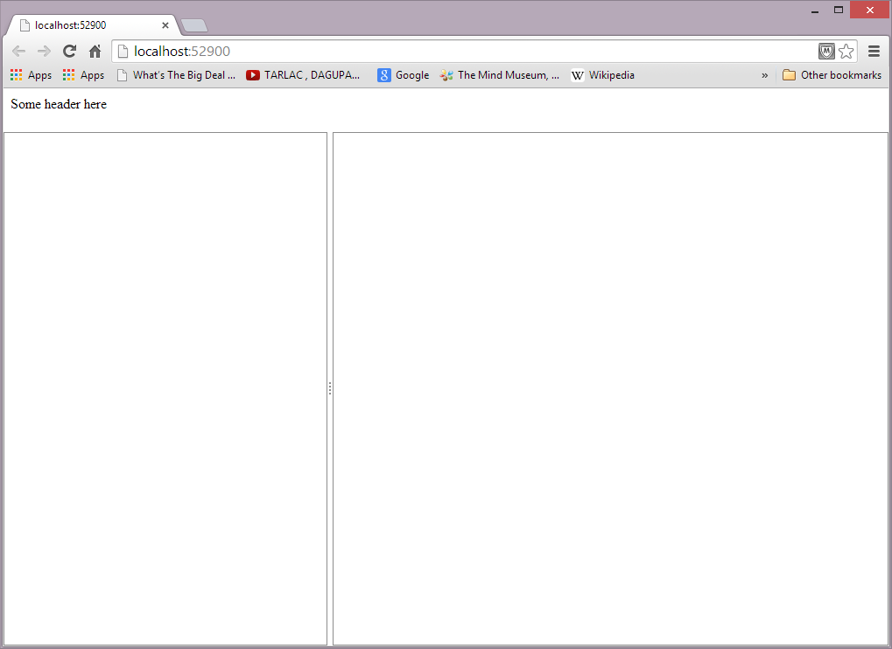

Figure Out How To Use Microsoft Expressions Web 4:

- See online tutorials.
- See: http://www.expression-web-designer-help.com/using_tables_in_expression_web.htm
- See about a book for this!!!
- /////

